**SmartSDLC-AI Enhancement Software Development Lifecycle**

**Project Documentation**

**1.Introduction**

1. Project title : SmartSDLC-AI Enhancement Software Development Lifecycle
2. Team member : A.NITHIYA

3. Team member : S.MAHESH

1. Team member : M.MEENAKSHI
2. Team member : A.NAGALAKSHMI

## 2. Project overview

**Purpose:**

1. Improve Efficiency: Streamline software development processes, reducing time and effort.

2. Enhance Quality: Improve software quality through AI-powered testing, code review, and analytics.

3. Accelerate Time-to-Market: Automate repetitive tasks, enabling faster deployment and release.

4. Data-Driven Decisions: Provide real-time insights and analytics, enabling data-driven decisions.

**Features:**

1. AI-Powered Code Review: Automated code review with AI-driven insights.

2. Intelligent Testing: AI-powered testing with predictive analytics and automated test generation.

3. Automated Deployment: Automated deployment with AI-powered workflows.

4. Real-Time Analytics: Real-time analytics and insights on project performance, quality, and efficiency.

5. Collaboration: Collaboration tools for development teams, stakeholders, and customers.

6. Predictive Maintenance: Predictive maintenance with AI-powered monitoring and alerts.

7. Continuous Feedback: Continuous feedback and insights to development teams.

# 3. Architecture

1. Development Environment: Integrated development environment (IDE) for coding, testing, and debugging.

2. AI-Powered Tools: Integration of AI-powered tools for code review, testing, and deployment.

3. Data Analytics Platform: Platform for collecting, analyzing, and visualizing project data.

4. Collaboration Platform: Platform for team collaboration, communication, and feedback.

5. Deployment Environment: Environment for deploying and managing software applications.

**4. Setup Instructions**

**Step 1: Define Project Requirements**

1. Identify Project Goals: Define project objectives, scope, and timelines.

2. Gather Requirements: Collect and document functional and non-functional requirements.

## Step 2: Choose AI-Powered Tools

## 1. Code Review Tools: Select AI-powered code review tools (e.g., Sonar Qube, Code Coverage).

## 2. Testing Tools: Choose AI-powered testing tools (e.g., Testim.io, Applitools).

## 3. Deployment Tools: Select AI-powered deployment tools (e.g., AWS Code Deploy, Google Cloud Deployment Manager).

## Step 3: Set Up Development Environment

## 1. IDE: Choose an integrated development environment (IDE) for coding, testing, and debugging.

## 2. Version Control: Set up version control systems (e.g., Git) for collaboration and tracking changes.

## 3. AI-Powered Tools Integration: Integrate AI-powered tools with the development environment.

## Step 4: Configure Data Analytics Platform

## 1. Data Storage: Set up a data storage solution (e.g., relational database, NoSQL database) for project data.

## 2. Data Analytics Tools: Choose data analytics tools (e.g., Tableau, Power BI) for visualizing project data.

## 3. AI-Powered Insights: Configure AI-powered insights and recommendations for project stakeholders.

## Step 5: Set Up Collaboration Platform

## 1. Communication Tools: Choose communication tools (e.g., Slack, Microsoft Teams) for team collaboration.

## 2. Project Management Tools: Select project management tools (e.g., Jira, Asana) for tracking progress and tasks.

## 3. Feedback Mechanisms: Establish feedback mechanisms for stakeholders to provide input and suggestions.

## 5. Folder Structure

## 1. Requirements: Requirements documents, specifications, and analysis.

## - Functional Requirements

## - Non-Functional Requirements

## - Use Cases

## 2. Design: Design documents, diagrams, and prototypes.

## - Architecture

## - UI/UX

## - Database

## 3. Development: Code repository for the project.

## - src: Source code

## - lib: Libraries and dependencies

## - tests: Unit tests, integration tests, and UI tests

## 4. AI Models: AI model definitions, training data, and evaluation metrics.

## - Model Definitions

## - Training Data

## - Evaluation Metrics

## 5. Testing: Testing scripts, test data, and test results.

## - Unit Tests

## - Integration Tests

## - UI Tests

## 6. Deployment: Deployment scripts, configurations, and logs.

## - Deployment Scripts

## - Configurations

## - Logs

## 7. Analytics: Analytics data, reports, and visualizations.

## - Data

## - Reports

## - Visualizations

## 8. Documentation: Project documentation, including user manuals and technical guides.

## - User Manuals

## - Technical Guides

## 

## 6. Running the Application

## 1. Deployment: Deploy the application to a production environment.

## 2. Monitoring: Monitor the application's performance, usage, and issues.

## 3. Maintenance: Perform regular maintenance tasks, such as updates, backups, and security checks.

## 4. AI-Powered Insights: Leverage AI-powered insights to identify areas for improvement and optimize the application.

## 7.API Documentation

1. Overview: High-level overview of the API, including its purpose and functionality.

2. Endpoints: Detailed documentation of each API endpoint, including request and response formats, parameters, and examples.

3. Authentication: Documentation on authentication mechanisms, including API keys, tokens, or other authentication methods.

4. Error Handling: Documentation on error handling, including error codes, messages, and troubleshooting tips.

**API Documentation Tools:**

1. Swagger: Open-source tool for API documentation, providing interactive API documentation and testing capabilities.

2. API Blueprint: Tool for API documentation, providing a simple and intuitive way to document APIs.

3. Postman: Tool for API testing and documentation, providing a user-friendly interface for testing and documenting APIs.

**8. Authentication**

1. Username/Password: Traditional username and password authentication.

2. API Keys: Unique API keys for secure access to APIs.

3. OAuth: Industry-standard authorization framework for secure access to APIs.

4. Two-Factor Authentication (2FA): Additional layer of security requiring a second form of verification.

**Benefits:**

1. Secure Access: Protects sensitive project data and APIs from unauthorized access.

2. Access Control: Enables fine-grained access control, allowing administrators to manage user permissions.

3. Auditing: Provides a record of user activity, enabling auditing and compliance.

## 9. User Interface

1. Dashboard: Centralized dashboard for project overview, metrics, and insights.

2. Project Management: UI for managing projects, including requirements, design, development, testing, and deployment.

3. AI-Powered Tools: Integration of AI-powered tools for code review, testing, and deployment.

4. Analytics: UI for real-time analytics and insights on project performance, quality, and efficiency.

5. Collaboration: UI for team collaboration, including communication, feedback, and task management.

**UI Features:**

1. Intuitive Navigation: Easy-to-use navigation and menu systems.

2. Customizable Dashboards: Customizable dashboards for personalized views.

3. Real-Time Updates: Real-time updates and notifications.

4. AI-Driven Insights: AI-driven insights and recommendations.

5. User-Friendly: User-friendly interface for developers, testers, and stakeholders.

## 10. Testing

1. Automated Test Generation: AI generates test cases automatically.

2. Intelligent Test Prioritization: AI prioritizes test cases based on risk and impact.

3. Predictive Analytics: AI predicts potential issues and defects.

4. Test Optimization: AI optimizes test cases and testing processes.

**Benefits:**

1. Increased Efficiency: AI-powered testing automates repetitive tasks and improves testing efficiency.

2. Improved Accuracy: AI-powered testing reduces human error and improves test accuracy.

3. Faster Time-to-Market: AI-powered testing accelerates testing processes, reducing time-to-market.

4. Enhanced Quality: AI-powered testing identifies potential issues and defects early on.

**11.Screen shots**

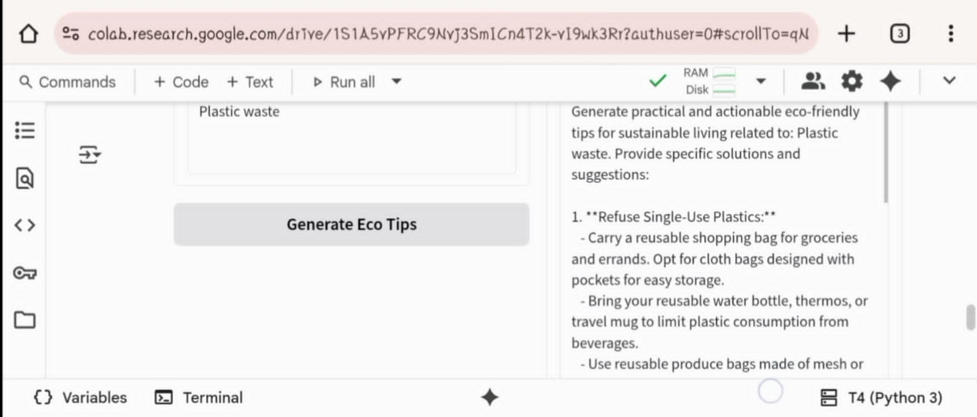

**12.Known Issues**

1. Data Quality Issues: Poor data quality can impact AI model accuracy and effectiveness.

2. Integration Challenges: Integrating AI-powered tools with existing systems and processes can be complex.

3. Model Bias: AI models can perpetuate biases present in training data, leading to unfair outcomes.

4. Explainability: AI models can be difficult to interpret, making it challenging to understand decision-making processes.

5. Security Risks: AI-powered systems can introduce new security risks, such as data breaches or model exploitation.

**13.Future enhancement**

- Increased Adoption of Generative AI: Global AI spending in SDLC is projected to nearly triple from $235 billion in 2024 to $630 billion by 2028, with generative AI accounting for a significant portion.

- Improved AI-Powered Testing: AI will continue to transform testing by generating test cases, detecting defects, and optimizing testing processes.

- Enhanced Code Generation: AI coding assistants will become more prevalent, with 90% of developers already using them for production-grade solutions.

- Intelligent Project Management: AI will simplify project management by delivering predictive analytics, real-time insights, and wise decision-making.

- Advanced DevOps and Deployment: AI will automate deployment, predict potential issues, and optimize rollback strategies.